**Name:** Muhammad Usman Waqar Khan

**Registration No:** SP23-BSE-010

Chapter 1

Use Case Diagrams

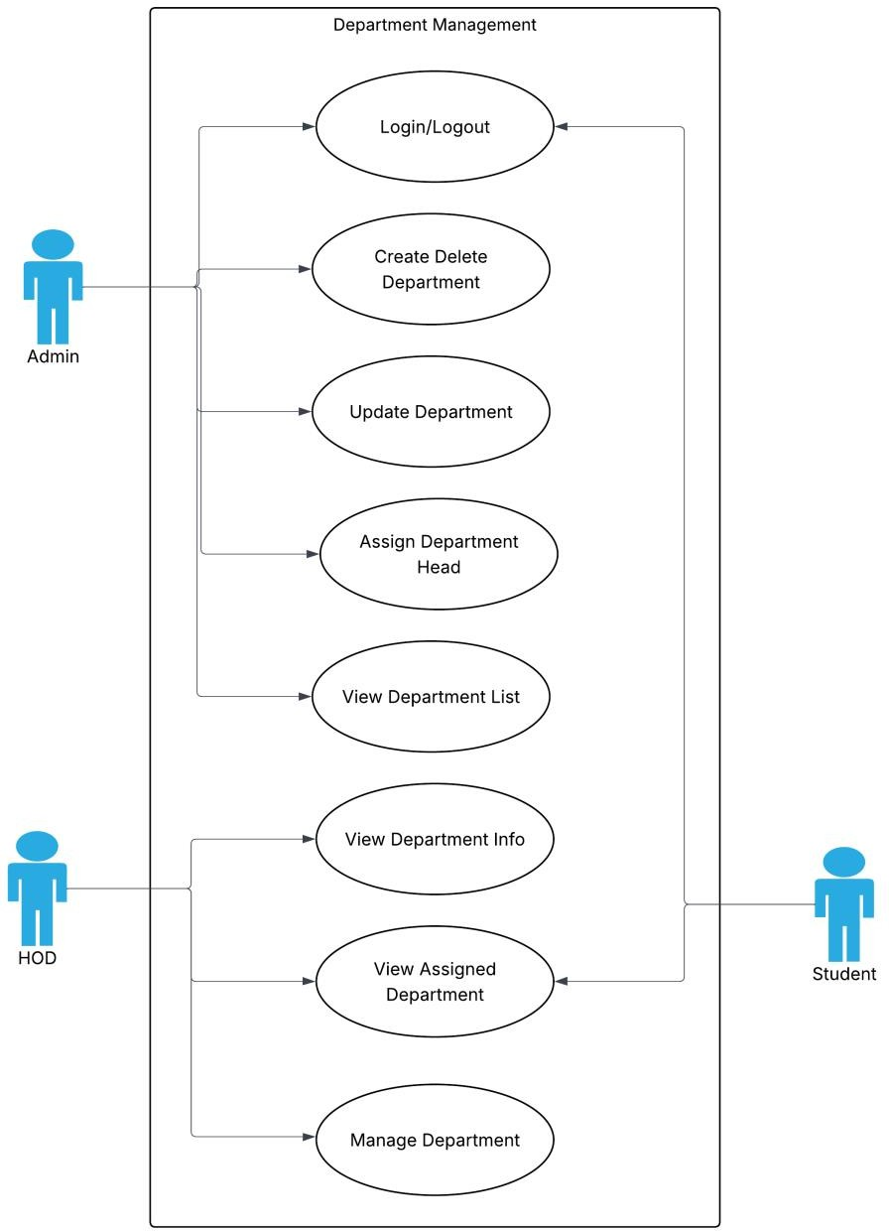

1. **Fully Dressed Use Cases**

**Name: M. Usman Waqar Khan**

|  |  |
| --- | --- |
| **Use Case Element** | **Details** |
| **Use Case Name** | Assign Department Head |
| **Primary Actor** | Admin (System Administrator) |
| **Goal in Context** | To assign a specific user (e.g., a teacher) as the Head of a selected department |
| **Scope** | User and Role Management Module |
| **Level** | User goal |
| **Stakeholders and Interests** | - **Admin** wants each department to have a responsible head- **System** ensures role control and department integrity- **New Head** should be properly notified and assigned necessary permissions |
| **Preconditions** | - Admin is authenticated and authorized- Departments and eligible users exist in the system |
| **Postconditions (Success)** | - The selected user is marked as Head for the chosen department and can access Head privileges |
| **Postconditions (Failure)** | - The system shows an error; no changes are made to department roles or user status |
| **Main Success Scenario** | 1. Admin selects "Assign Department Head" 2. Admin chooses department 3. System shows current head (if any) and eligible users 4. Admin selects a user 5. Admin confirms 6. System saves assignment and shows success |
| **Extensions (Alternate Flows)** | - **2a.** No departments → System shows: "No departments available"-  **3a.** No eligible users → System shows: "No eligible users for this  department"-  **4a.** Admin cancels → System exits-  **5a.** Error saving → System shows error message |
| **Special Requirements** | - Only one Head per department allowed- Assigned user must be a teacher or staff- System logs the assignment in audit trail |
| **Frequency of Use** | Occasionally — only when assigning or changing department heads |
| **Open Issues** | - Should previous Head be notified or auto-demoted? - Should the new Head receive extra privileges instantly? |

1. **System Sequence Diagram Name: M. Usman Waqar Khan**

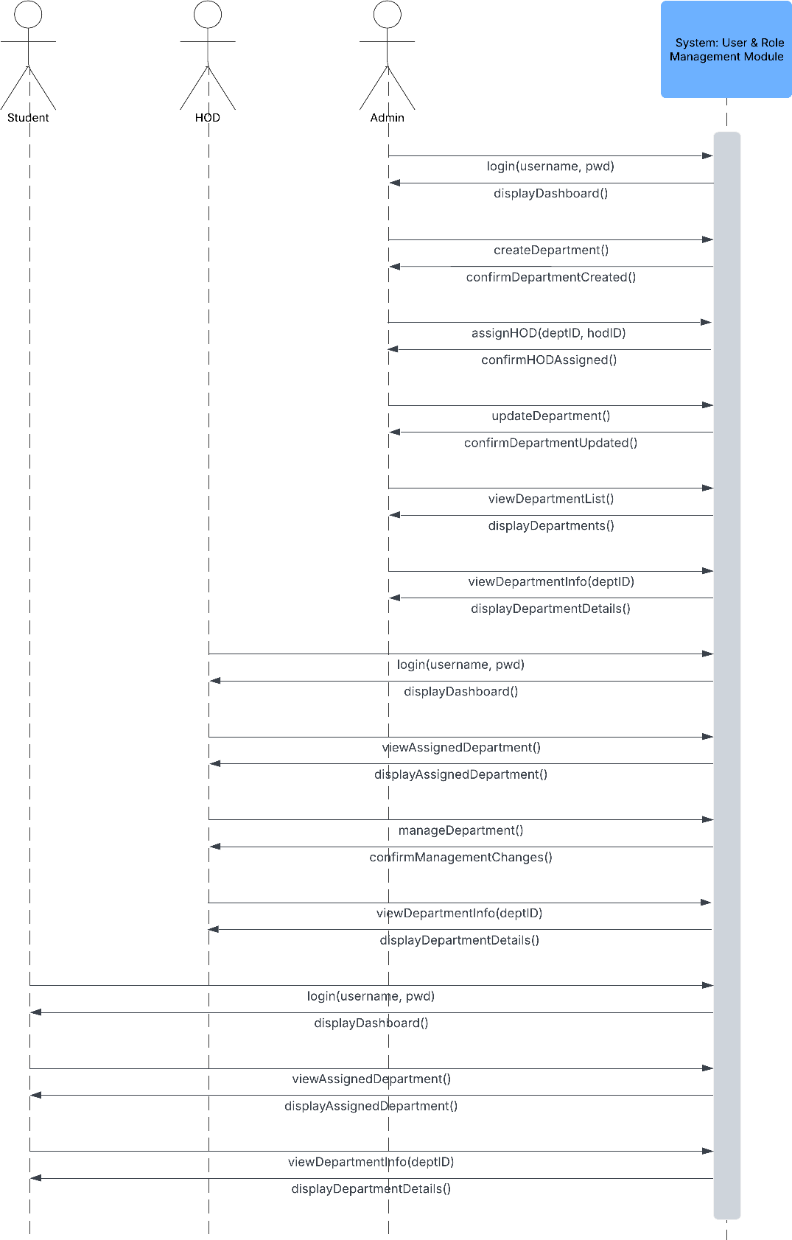

**4.Package Diagram**

**Name: M. Usman Waqar Khan**

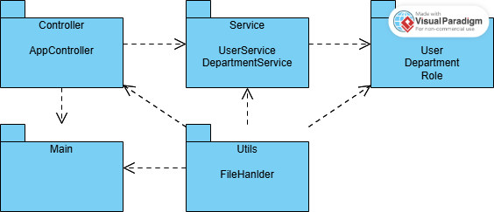

**5. Class Diagram**

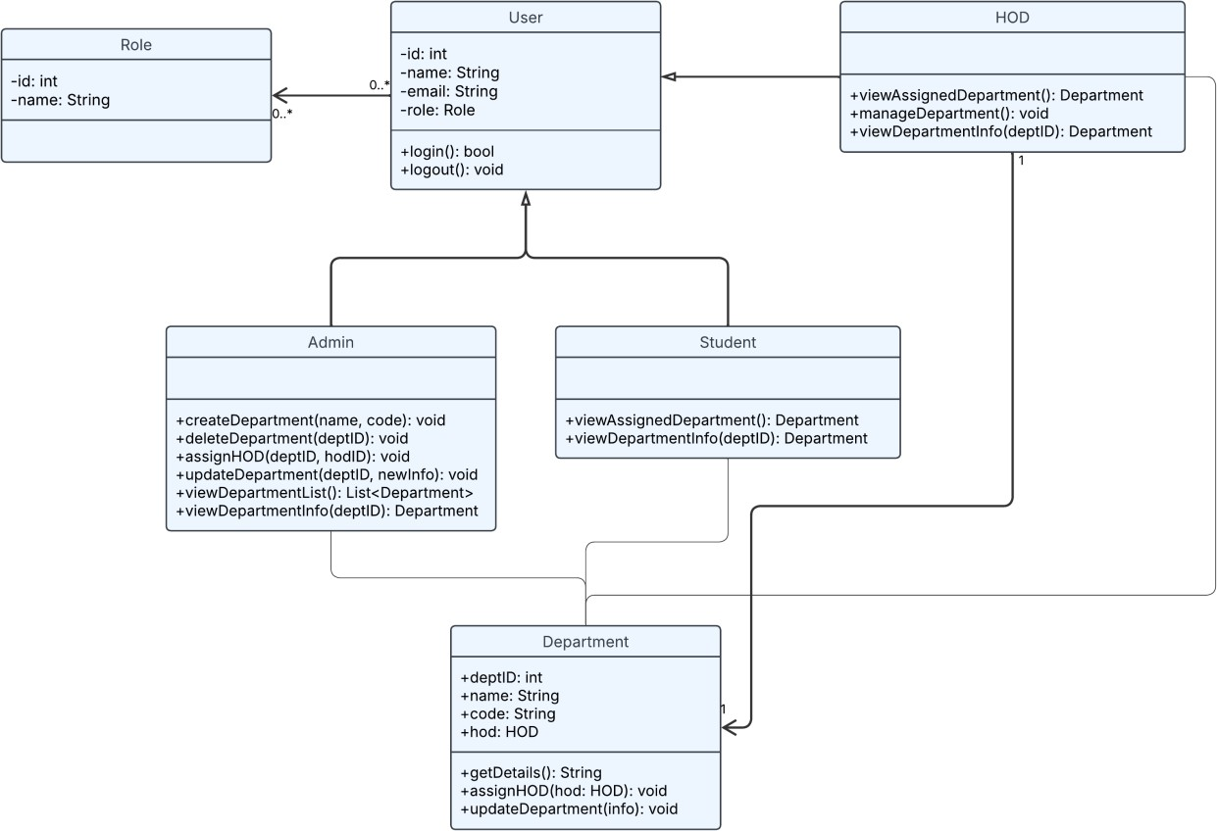

**6. Coding Standards**

✅ 1. Project Structure & Naming

|  |  |
| --- | --- |
| **Standard** | **Example** |
| Package names | model, service, controller, utils, db (all lowercase) |
| Class names | DepartmentService, UserController (PascalCase) |
| Variable names | departmentList, userId (camelCase) |
| Constants | public static final int MAX_USERS = 100; (ALL_CAPS) |
| File names | Match the class name exactly (e.g., User.java) |

✅ 2. Class & Method Standards

|  |  |
| --- | --- |
| **Guideline** | **Description** |
| One class per file | Makes debugging and collaboration easier |
| Class should be single responsibility | Department holds data, DepartmentService holds logic |
| Methods should do **one** task only | Split large methods into helper functions |
| Method names in verbs | createUser(), assignRole(), getDepartmentById() |

✅ 3. Comments & Documentation

|  |  |
| --- | --- |
| **Type** | **Guideline** |
| Class comments | Explain class purpose and responsibilities |
| Method comments | Use /** Javadoc */ for public methods |
| Inline comments | Only when logic isn’t obvious |
| Block comments | Use to separate logical sections inside larger methods |

**Example:**

/**

* Assigns a department head (HOD) to the given department.
* @param deptId The ID of the department.
* @param hod The user to assign as HOD.

*/

public void assignHOD(int deptId, User hod) {

...

}

✅ 4. Code Formatting

|  |  |
| --- | --- |
| **Practice** | **Details** |
| Indentation | 4 spaces (no tabs) |

|  |  |
| --- | --- |
| **Practice** | **Details** |
| Brackets | Always use curly braces {} even for one-liners |
| Line Length | Wrap lines after ~100 characters |
| Blank Lines | Use between methods or logical blocks for readability |
| Group imports | Java standard, then third-party, then project imports |

✅ 5. Error Handling

|  |  |
| --- | --- |
| **Rule** | **Example** |
| Use meaningful messages | throw new IllegalArgumentException("User not found with ID: " + id); |
| Catch specific exceptions | Don’t use just Exception |
| Avoid silent failures | Always log or report errors |

✅ 6. Modularity & Reusability

|  |  |
| --- | --- |
| **Best Practice** | **Description** |
| Don’t hardcode values | Use constants or config files |
| Avoid duplicate code | Reuse methods and utilities |
| Break down logic | Keep services small and focused |
| Interfaces for services | Helps in testing and future DB integration |

✅ 7. Version Control Standards (Git/GitHub)

|  |  |
| --- | --- |
| **Rule** | **Description** |
| Use feature branches | e.g., feature/user-management-module |
| Commit often | Small, meaningful commits |
| Use clear commit messages | "Add DepartmentService with create/update logic" |
| Pull and merge regularly | Avoid long-running branches |
| Document module usage | In README.md or JavaDocs |

Name: Usman Jamil Abbasi 1: Use-Case Diagram:

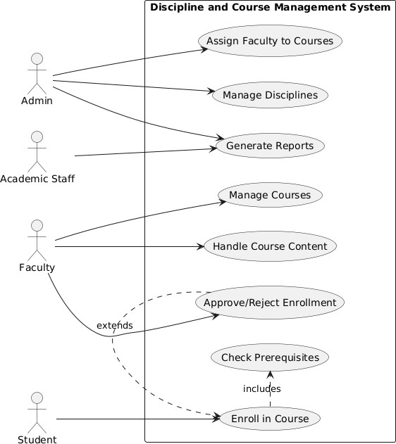

1. Fully Dressed Use Cases:

|  |  |
| --- | --- |
| **Field** | **Details** |
| **Use Case Name** | Enroll in Course |
| **Primary Actor** | Student |
| **Secondary Actors** | System, Faculty |
| **Preconditions** | - Student is logged in- Course exists and has available seats |
| **Main Success Scenario** | 1. Student selects desired course from catalog 2. System verifies course availability and prerequisites (UC8)3. System creates enrollment record 4. System notifies faculty of new enrollment 5. System confirms successful enrollment of student |
| **Extensions** | **3a. Prerequisites not met:** - System displays missing requirements - Use case ends unsuccessfully**3b. Course is**  **full:** - System adds student to waitlist - System notifies student of waitlist position |
| **Special**  **Requirements** | - Enrollment window must be open- Real-time seat availability check |
| **Postconditions** | - If successful: Enrollment record created- If waitlisted: Waitlist position assigned |
| **Related Use Cases** | - **Includes:** Check Prerequisites (UC8)- **Extended by:**  Approve/Reject Enrollment (UC7) |
| **Frequency of Occurrence** | High (hundreds per day during registration periods) |

1. System Sequence Diagram:

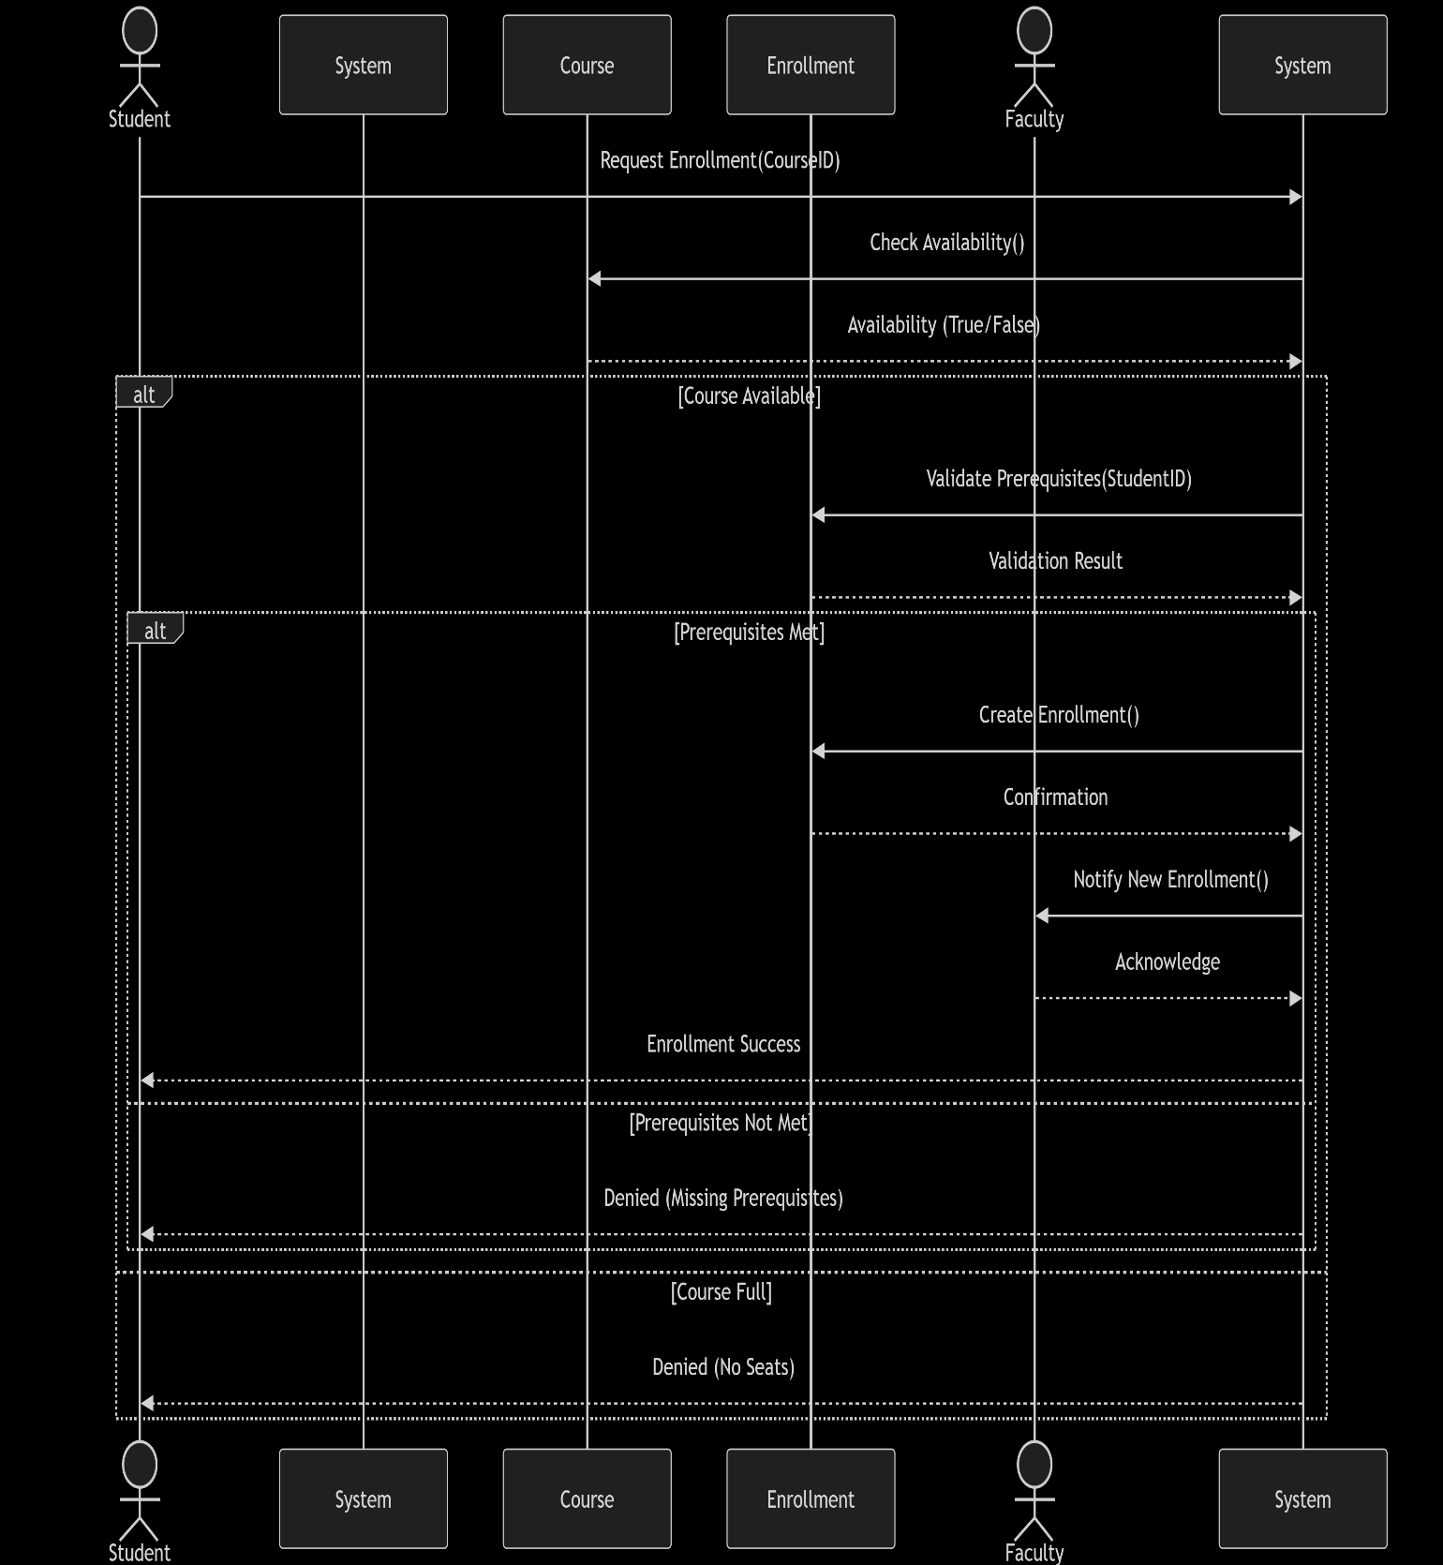

1. Class Diagram:

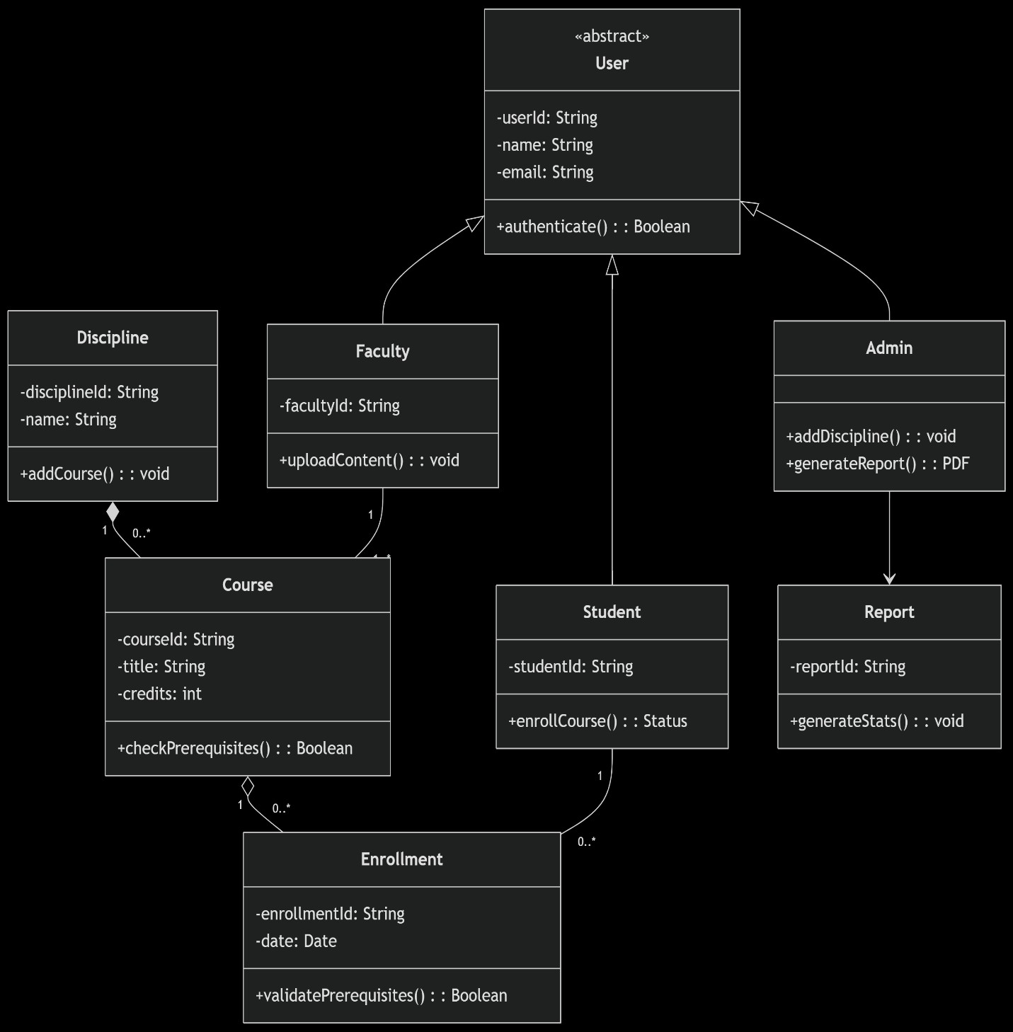

1. Package Diagram:

